Data Hiding :
Our internal data should not go out directly that is outside person can't access
our internal data directly.
By using private modifier we can implement data hiding.

Example:
class Account {
private double balance;
......................;
......................;
}
The main advantage of data hiding is security.
Note: recommended modifier for data members is private

Abstraction
Hide internal implementation and just highlight the set of services, is called
abstraction.
By using abstract classes and interfaces we can implement abstraction.
Example :
By using ATM GUI screen bank people are highlighting the set of services what they
are offering without highlighting internal implementation.

The main advantages of Abstraction are:
1. We can achieve security as we are not highlighting our internal
implementation.(i.e., outside person doesn't aware our internal implementation.)
2. Enhancement will become very easy because without effecting end user we can
able to perform any type of changes in our internal system.
3. It provides more flexibility to the end user to use system very easily.
4. It improves maintainability of the application.
5. It improves modularity of the application.

Encapsulation :
Binding of data and corresponding methods into a single unit is calledEncapsulation.
If any java class follows data hiding and abstraction such type of class is said to
be encapsulated class.
Encapsulation=Datahiding+Abstraction

Every data member should be declared as private and for every member we have to
maintain getter & Setter methods.

The main advantages of encapsulation are :
1. We can achieve security.
2. Enhancement will become very easy.
3. It improves maintainability and modularity of the application.
4. It provides flexibility to the user to use system very easily.
The main disadvantage of encapsulation is it increases length of the code and slows
down execution.

Inheritence or IS -A relationship:
Inheritance is a mechanism in which one class acquires the property of another class. For example, a child inherits the traits of his/her parents. With inheritance, we can reuse the fields and methods of the existing class. Hence, inheritance facilitates Reusability and is an important concept of OOPs.
Inheritance:
Deriving new classes from existing classes such that the new classes acquire all feature of existing classes is called inheritance.

Why super class members are available to sub class.
Ans: sub class object contains copy of super class object

What is advantage of inheritance?
Aprogrammer reuses super class code without rewriting it. In creation of sub classes, so developing become very easy, hence the program productivity increased.

Why multiple inheritances not supported in java
multiple inheritances lead to confusion for the programmer
Example: class A has got a member X and class B has also got a member X, when another class C extends both classes then there is a confusion regarding which copy of X is available

By using extending keyword we implement IS_A relation ship
The main advantage of inherence is reusability

Conclusion :

1. Whatever the parent has by default available to the child but whatever the child
has by default not available to the parent. Hence on the child reference we can
call both parent and child class methods. But on the parent reference we can call
only methods available in the parent class and we can't call child specific
methods.

2. Parent class reference can be used to hold child class object but by using that
reference we can call only methods available in parent class and child specific
methods we can't call.

3. Child class reference cannot be used to hold parent class object.

https://www.geeksforgeeks.org/inheritance-in-java/

HAS-A relationship or composition:lip:
- HAS-A relationship is also known as composition (or) aggregation.
- There is no specific keyword to implement HAS-A relationship but mostly we
Can use new operator.
- The main advantage of HAS-A relationship is reusability.

Example:
class Engine
{
//engine specific functionality
}
class Car
{
Engine e=new Engine();
//........................;
//........................;
//........................;
}
- class Car HAS-A engine reference.
- The main dis-advantage of HAS-A relationship increases

What is difference Composition and Aggregation

Composition

final class Car {

private final Engine engine;

Car(EngineSpecs specs) {
engine = new Engine(specs);
}

void move() {
engine.work();
}
}

Aggregation

final class Car {

private Engine engine;

void setEngine(Engine engine) {
this.engine = engine;
}

void move() {
if (engine != null)
engine.work();
}
}

In the case of composition, the Engine is completely encapsulated by the Car. There is no way for the outside world to get a reference to the Engine. The Engine lives and dies with the car. With aggregation, the Car also performs its functions through an Engine, but the Engine is not always an internal part of the Car. Engines may be swapped, or even completely removed. Not only that, but the outside world can still have a reference to the Engine, and tinker with it regardless of whether it's in the Car.

Super Keyword
The super keyword is similar to "this" keyword.
The keyword super can be used to access any data member or methods of the parent class.
Super keyword can be used at variable, method and constructor level.

Polymorphism

Same name with different forms is the concept of polymorphism.
Example 1: We can use same abs() method for int type, long type, float type etc.

Example:
1. abs(int)
2. abs(long)
3. abs(float)

- Inheritance talks about reusability.
- Polymorphism talks about flexibility.
- Encapsulation talks about security.

Method signature:
Method signature nothing but method name along with parameter

method overloading is an example of compile time/static polymorphism because method binding between method call and method definition happens at compile time and it depends on the reference of the class (reference created at compile time and goes to stack).

Writng two or more methods in same class in such way that each method has same name but with different orgumensts.

method overriding is an example of run time/dynamic polymorphism because method binding between method call and method definition happens at run time and it depends on the object of the class (object created at runtime and goes to the heap).

Writng two or more methods in super and sub class in such way that each method has same name andsameorgumensts.

Dynamic (run time) polymorphism is the polymorphism existed at run-time. Here, Java compiler does not understand which method is called at compilation time. Only JVM decides which method is called at run-time. Method overloading and method overriding using instance methods are the examples for dynamic polymorphism.

Static (compile time) polymorphism is the polymorphism exhibited at compile time. Here, Java compiler knows which method is called. Method overloading and method overriding using static methods; method overriding using private or final methods are examples for static polymorphism

While overriding if the child class method throws any checked exception
compulsory the parent class method should throw the same checked exception or its
parent otherwise we will get compile time error.
But there are no restrictions for un-checked exceptions.

Example:
class Parent {
public void methodOne() {}
}
class Child extends Parent{
public void methodOne() throws Exception {}
}

Output:
Compile time error :
methodOne() in Child cannot override methodOne() in Parent;
overridden method does not throw java.lang.Exception

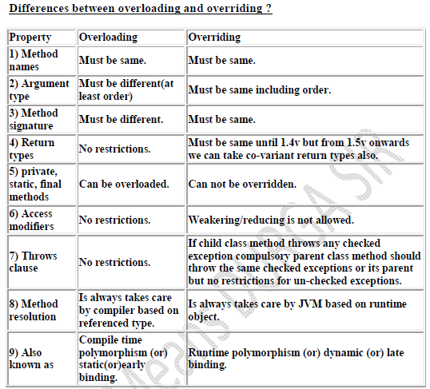

Note:

In overloading we have to check only method names (must be same) and
arguments (must be different) the remaining things like return type extra not
required to check.

But In overriding we should compulsory check everything like method names,
arguments, return types, throws keyword, modifiers etc.

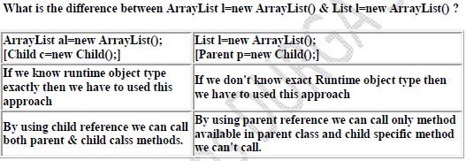

When you declare List l = new ArrayList() l is limited to the methods provided by the interface List,
while when you declare it ArrayList al = new ArrayList() it can use all methods and fields in an arraylist.

When you declare it List l then you afford yourself more flexibility as you can change out the ArrayList for something more appropriate at a later date if you want to without breaking any code.

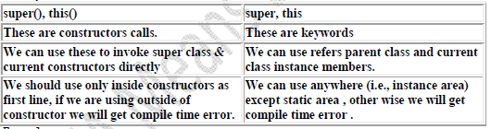

Static method:
Static methods do not act up on instance variable of the class, static methods are declared as static.
To call the static method no need to create objects.

Why static method not accessible
Jvm first executes static methods and then only create objects, since objects are not available at time of calling static method.

Different between Static variable (class variable) and instance variable
Instance variable is separate copy is available to each object .
In case of Class variable single copy in memory is shared by all the objects.
Instance variable are created in objects on heap memory , static variables stored on method area.

Instance variable is separate copy is available to each object , the value of instance variable is modified in an object does not affect the instance variable in other objects.

Static variable will have only one copy in memory that is shared by all the objects, any modification done variable in object it will affect up on other objects.

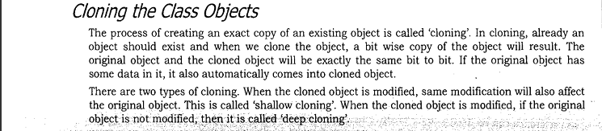

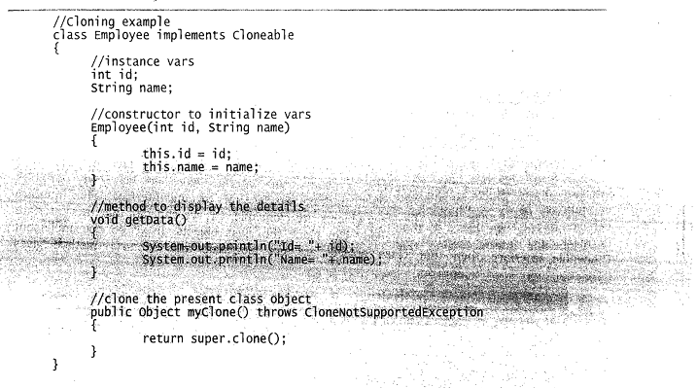

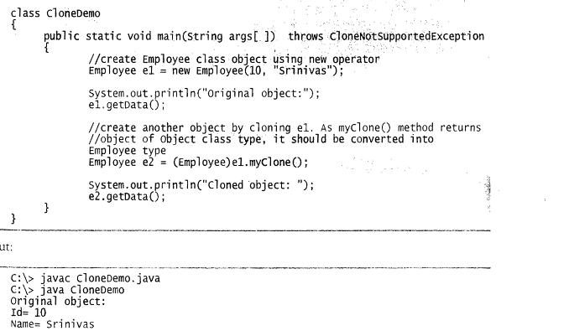

Exception Handling

Exception: An unwanted unexpected event that disturbs normal flow of the program is
called exception.
Example:
SleepingException
TyrePunchuredException
FileNotFoundException ...etc

It is highly recommended to handle exceptions. The main objective of exceptionhandling is graceful (normal) termination of the program.

What is the meaning of exception handling?

Exception handling doesn't mean repairing an exception. We have to define alternative
way to continue rest of the program normally. This way of defining alternative is
nothing but exception handling.

Example: Suppose our programming requirement is to read data from remote filelocating at London. At runtime if London file is not available then our program shouldnot be terminated abnormally.
We have to provide a local file to continue rest of the program normally. This way ofdefining alternative is nothing but exception handling.

Example:
try
{
read data from London file
}
catch(FileNotFoundException e)
{
use local file and continue rest of the program normally
}

Exception:
Most of the cases exceptions are caused by our program and these are recoverable.
Ex : If FileNotFoundException occurs then we can use local file and we can continue
rest of the program execution normally.
Error:
Most of the cases errors are not caused by our program these are due to lack of system
resources and these are non-recoverable.
Ex :IfOutOfMemoryError occurs being a programmer we can't do anything the
program will be terminated abnormally.System Admin or Server Admin is responsible
to raise/increase heap memory.

Checked exceptions
A checked exception is an exception that occurs at the compile time, these are also called as compile time exceptions. These exceptions cannot simply be ignored at the time of compilation, the programmer should take care of (handle) these exceptions.
For example, if you use FileReader class in your program to read data from a file, if the file specified in its constructor doesn't exist, then a FileNotFoundException occurs, and the compiler prompts the programmer to handle the exception.

Example
Live Demo
importjava.io.File;
importjava.io.FileReader;
publicclassFilenotFound_Demo{

publicstaticvoidmain(Stringargs[]){
Filefile=newFile("E://file.txt");
FileReaderfr=newFileReader(file);
}
}
If you try to compile the above program, you will get the following exceptions.

Output
C:\>javac FilenotFound_Demo.java
FilenotFound_Demo.java:8: error: unreported exception FileNotFoundException; must be caught or declared to be thrown
FileReaderfr=newFileReader(file);
^
1 error
Note − Since the methods read() and close() of FileReader class throws IOException, you can observe that the compiler notifies to handle IOException, along with FileNotFoundException.

Unchecked exceptions
An unchecked exception is an exception that occurs at the time of execution. These are also called as Runtime Exceptions. These include programming bugs, such as logic errors or improper use of an API. Runtime exceptions are ignored at the time of compilation.
For example, if you have declared an array of size 5 in your program, and trying to call the 6th element of the array then an ArrayIndexOutOfBoundsExceptionexception occurs.

Example
Live Demo
publicclassUnchecked_Demo{
publicstaticvoidmain(Stringargs[]){
intnum[]={1,2,3,4};
System.out.println(num[5]);
}
}
If you compile and execute the above program, you will get the following exception.

Output
Exceptionin thread "main"java.lang.ArrayIndexOutOfBoundsException:5
at Exceptions.Unchecked_Demo.main(Unchecked_Demo.java:8)

Exceptions List:
Unchecked Exception List
ArrayIndexOutOfBoundsException
ClassCastException
IllegalArgumentException
IllegalStateException
NullPointerException
NumberFormatException
AssertionError
ExceptionInInitializerError
StackOverflowError
NoClassDefFoundError

Checked Exception List
Exception
IOException
FileNotFoundException
ParseException
ClassNotFoundException
CloneNotSupportedException
InstantiationException
InterruptedException
NoSuchMethodException
NoSuchFieldException

Difference between throw and throws in Java
There are many differences between throw and throws keywords. A list of differences between throw and throws are given below:

Throw:
Sometimes we can create Exception object explicitly and we can hand over to the JVMmanually by using throw keyword
Note: In general we can use throw keyword for customized exceptions but not for
predefined exceptions.

No. | Throw | throws
1) | Java throw keyword is used to explicitly throw an exception. | Java throws keyword is used to declare an exception.
2) | Checked exception cannot be propagated using throw only. | Checked exception can be propagated with throws.
3) | Throw is followed by an instance. | Throws is followed by class.
4) | Throw is used within the method. | Throws is used with the method signature.
5) | You cannot throw multiple exceptions. | You can declare multiple exceptions e.g.  public void method()throws IOException,SQLException.



Example Program
publicclassMyExceptionextends Exception {

privatestaticfinallongserialVersionUID = 4664456874499611218L;

private String errorCode = "Unknown_Exception";

publicMyException(String message, String errorCode) {
super(message);
this.errorCode = errorCode;
}

public String getErrorCode() {
returnthis.errorCode;
}
}

publicclassCustomExceptionExample {

publicstaticvoidmain(String[] args) throwsMyException {
try {
processFile("file.txt");
} catch (MyExceptione) {
processErrorCodes(e);
}
}

privatestaticvoidprocessErrorCodes(MyExceptione) throwsMyException {
switch(e.getErrorCode()){
case"BAD_FILE_TYPE":
System.out.println("Bad File Type, notify user");
throwe;
case"FILE_NOT_FOUND_EXCEPTION":
System.out.println("File Not Found, notify user");
throwe;
case"FILE_CLOSE_EXCEPTION":
System.out.println("File Close failed, just log it.");
break;
default:
System.out.println("Unknown exception occured, lets log it for further debugging."+e.getMessage());
e.printStackTrace();
}
}

privatestaticvoidprocessFile(String file) throws MyException {
InputStreamfis = null;
try {
fis = newFileInputStream(file);
} catch (FileNotFoundExceptione) {
thrownewMyException(e.getMessage(),"FILE_NOT_FOUND_EXCEPTION");
}finally{
try {
if(fis !=null)fis.close();
} catch (IOExceptione) {
thrownewMyException(e.getMessage(),"FILE_CLOSE_EXCEPTION");
}
}
}

}

Difference between final, finally, and finalize:
final:
- final is the modifier applicable for classes, methods and variables.
- If a class declared as the final then child class creation is not possible.
- If a method declared as the final then overriding of that method is not
- If a variable declared as the final then reassignment is not possible

finally:
finally is the block always associated with try-catch to maintain clean up code
which should be executed always irrespective of whether exception raised or not
raised and whether handled or not handled.

finalize
finalize is a method, always invoked by Garbage Collector just before destroying
an object to perform cleanup activities.

Note:
1. finally block meant for cleanup activities related to try block where asfinalize()
method meant for cleanup activities related to object.
2. To maintain clean up code finally block is recommended over finalize() method
because we can't expect exact behavior of GC.

